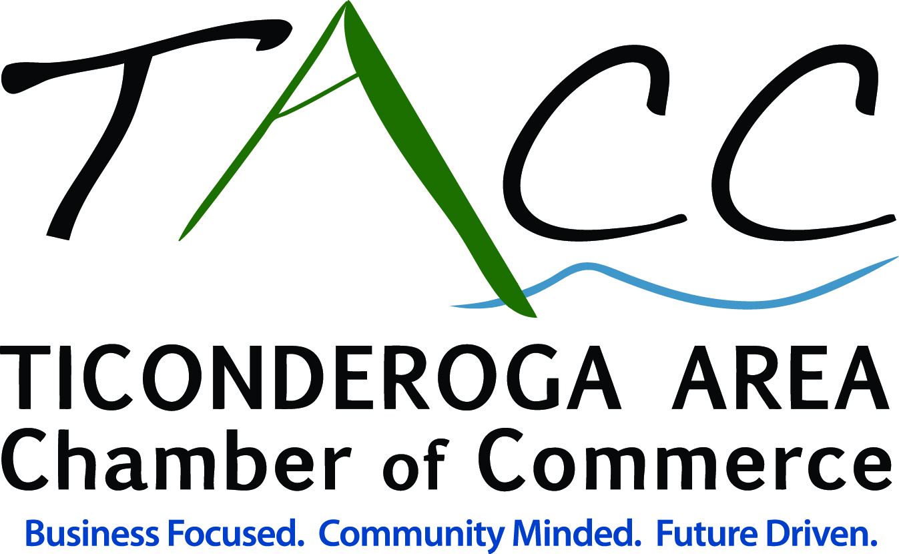

Press Release

FOR IMMEDIATE RELEASE:

CONTACT:

Matthew Courtright, Executive Director

Ticonderoga Area Chamber of Commerce

mcourtright@ticonderogany.com or 518-585-6619

January/New Year Networking Opportunity

Ticonderoga, NY – December 21, 2015 – The Ticonderoga Area Chamber of Commerce (TACC) January/New Year After Business Mixer will be held on Thursday, January 21, 2016 at the office of Sun Community News/Times of Ti and Alexander R. Shmulsky Attorney At Law from 5:30 – 7:00 PM. The offices of Sun Community News and Alexander R. Shmulsky are located at 102 Montcalm Street in Ticonderoga, NY. Sponsors providing door prizes are Bridge Point Communication, Christopher Chevrolet Buick, Hair It Is, Serenity Therapeutic Massage, and the Wagon Wheel Restaurant.

“We invite all Chamber Members, area businesses, and organizations to join us as we kick off the New Year. We will issue our 2016 “Save The Date” of events, share information on the positive and productive year ahead, and much more. You will also have a chance to hear from our hosts, as well as connect with fellow Chamber Members, businesses, and organizations,” shared Matthew Courtright – TACC Executive Director.

The Chamber’s “After Business Mixers” provide a networking forum for Chamber Members and area business people in addition to showcasing the site of the host as well as promoting the door prize sponsors. Networking is a key component of Chamber membership and marketing your business. Chamber members, area businesses, and organizations are encouraged to take advantage of this and all networking opportunities. Join the Chamber to reconnect with area businesses and organizations, meet new people, and take advantage of the opportunity to hear from the hosts.

“Sun Community News/Times of Ti is pleased to be co-hosting the first Chamber After Business Mixer of 2016 with Alex Shmulsky. We look forward to seeing the local business community on January 21st here at 102 Montcalm Street in downtown Ticonderoga. We invite you to come out, enjoy good food, drinks and conversation. Thank you to the chamber and their staff for the continued support and dedication to our business community, the Ticonderoga Area as a whole and for organizing the many trainings, services, and events that benefit the community and visitors all year long,” shared Scarlette Merfeld – Southern Manager, Sun Community News/Times of Ti.

Sun Community News/Times of Ti Sun is a weekly local community newspaper mailing to over 8,000 homes in Southern Essex County. Sister paper to a group of 7 newspapers distributing to more than 52,000 homes weekly through the north country, with a 99.1% of household readership.

MORE
Sun Community News offers a leading medium in the area to deliver your message through our newspapers as well as through printing that can meet all of your needs. Sun Community News in addition to their weekly papers and advertising opportunties offers design and printing of post cards, newsletters, brochures, posters, vinyl banners, yard signs, rack cards, and more. For more information call 518-585-9173 or visit www.suncommunitynews.com.

“We are very proud to be a member of the Ticonderoga Area Chamber of Commerce. The chamber provides many opportunities throughout the year for education, trainings, community events, business referrals, and networking. For our law practice, networking plays a major role, and I am so thankful to be a part of such an active chamber. The chamber is quintessential for any business owner in the Ticonderoga and greater Ticonderoga areas,” stated Alexander R. Shmulsky.

Alexander Shmulsky Attorney at Law is a full service lawyer, serving businesses, individuals and families throughout New York and Massachusetts. Practice areas include: Business Law, Criminal Defense, Uncontested Divorce, Personal Injury, Real Estate Law and Family Court. Alexander R. Shmulsky has offices located in Ticonderoga, New York and Saratoga Springs, New York. Alexander R. Shmulsky Attorney At Law is committed to providing efficient and effective legal representation and is licensed in New York and Massachusetts. For more information call (518) 585-4400 or visit www.shmulskylaw.com.

For more information on the After Business Mixer contact the Ticonderoga Area Chamber of Commerce at 518-585-6619 or via email at chamberinfo@ticonderogany.com.

The Ticonderoga Area Chamber of Commerce – The Ticonderoga Area Chamber of Commerce (TACC) is a non-profit organization that serves, markets, and promotes the Ticonderoga area including, Ticonderoga, Crown Point, Hague, Moriah, and Putnam, NY. The mission of the TACC is to initiate and provide programs, services, and leadership
which will enhance a cooperative business community and create a vibrant economy, making the Ticonderoga Area an exceptional place to live, work, and visit. For more information on the Ticonderoga Area Chamber of Commerce or the Ticonderoga Area please visit www.ticonderogany.com, “like” the Chamber on facebook, “follow” TiconderogaADK on twitter, and TiconderogaNY on Instagram.

###

