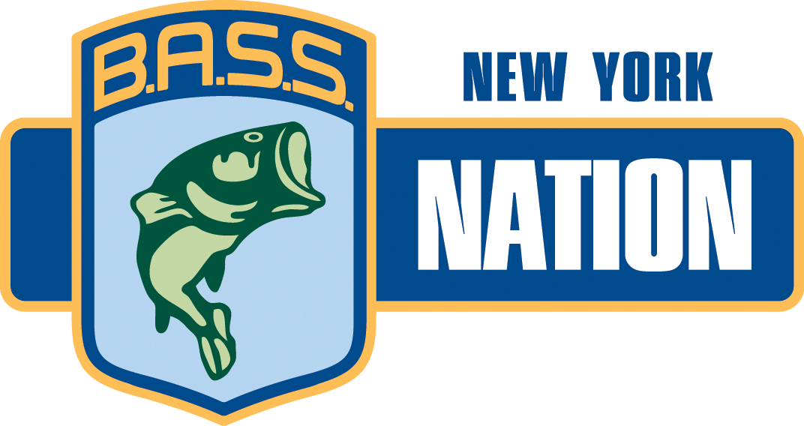
Date: 08/24/2015
Contact: Fred Blom
NYBCF Spokesperson
Tel: 585-748-6222
Email: pr@nybassfed.com

– FOR IMMEDIATE RELEASE –

Rochester Bassmasters comes from behind to win 2015 New York BASS Nation Rosemary Murphy Club Team Championship

Ticonderoga, New York---It has seemed like the entire 2015 New York BASS Nation tournament season has been dodging rain drops. Forecasts have been ominous and at times, we have had light rain or a thunderstorm nearby but up until the Club Team Championship, no direct hits. Ticonderoga Supervisor Bill Grinnell welcomed us on Friday with the promise of “no rain” and so we set up the registration and the predictions came true as we enjoyed a typical August afternoon with warm temperatures and some sunshine.

Saturday morning followed with clear skies. The anglers launched quickly and we were able to start releasing the first flight at 5:45 am. Everyone was off safe and sound. The tournament crew kept a close eye on the radar as we began weighing fish. First flight made it in and had no problems. Early on we knew the angling would be good as Frank Giner from Westchester Rod and Reel weighed in a largemouth bass at 6.34 pounds. Second flight in and near the end of that flight, Frank’s big fish was displaced by a 6.39 pound largemouth caught by Mike Lapointe from Washington County Bassmasters.
Mike’s total weight of 19.74 helped lead his team into contention for day two.

Then the wind and thunder started. Reports came in that two miles away, it was raining. Within minutes, the weighin was hit with huge thunderstorms, a micro burst of wind that took out the tents and a deluge of rain which ultimately lasted 40 minutes. Everyone survived but the third flight anglers struggled with visibility as they got their boats off the water. When the weighin resumed, the remaining anglers finished weighing their fish without incident. Day one standings had Washington County Bassmasters lead by Mike LaPointe in first place, followed by Westchester Rod and Reel, Rochester Bassmasters, Crown City Bassmasters and Port City Bassmasters.

Day two launched and ran without weather incident. Teams were excited as each of the six members came to the scales. Not only were there the team championship standings and payouts at stake, three anglers would be securing spots on the Regional Championship Team for 2016. As anglers came to the scales, excitement would build. This was especially true for Salt City and angler Brian Eisch. Brian came in with the leading individual weight for the day at 19.57 pounds but also took big fish honors for the day with a 5/74 pound largemouth.

The big turn was in the final team standings. Rochester Bassmasters had a solid first day but then followed up with an even better second day and came from third place to first place and became the 2015 Club Team Champions. TJ Valle lead the team with 32.56 total pounds followed by Ronnie Penders Jr., Jim Bianchi, Tom Hughes, Bill Wittman and Pat Carr for a total team weight of 141.65 pounds. In second place was Crown City with 139.42 pounds, third place was Port City Bassmasters with 132.34 pounds, fourth place was Washington County Bassmasters with 132.32 pounds and in fifth place was Statewide Bassmasters with 129.38 pounds.
TJ Valle from Rochester Bassmasters, Chris Killoren from Crown City Bassmasters, and Noel Good from Southern Tier Bassmaters qualified to become members of the 2016 New York Regional Championship Team.

Many thanks to Ticonderoga, our host community, where we will return in June 2016 to open our season. The anglers and their families took advantage of the many attractions, shops and restaurants during their stay and look forward to returning next year.

About the NYBN…The New York B.A.S.S. Nation (NYBN) has been operating for over 40 years and its 50 plus B.A.S.S. sanctioned bass chapter clubs, represent more than just tournament fishing. We fulfill our mission to promote and protect the sport of bass fishing by organizing award winning programs in youth, conservation and community service. Associated with Bass Anglers Sportsman’s Society, the NYBCF is the New York region’s foremost advocate for bass fishing and fisherman’s rights. The Federation offers a competitive annual tournament tour and extensive youth and conservation projects. Some of our members have proudly advanced into the professional ranks and competed in national level competitions.

###

Photo Attachments:

Photo #1 – 2015 Club Team Champions Rochester Bassmasters L to R Bill Wittman, TJ Valle, Tom Hughes, Jim Bianchi, Pat Carr, Ronnie Penders Jr.

Photo #2 - 2015 Club Team Second place Crown City Bassmasters L to R Todd Covert, Luke Matt, John Badman, RC Bobbett, Joe Matt, Chris Killoren

Photo #3 - 2015 Club Team Third Place Port City Bassmasters L to R Ron Bracy, Steve Pickard, Doug Linn, Craig Seeley, Ken Bracy, Gary Day

Photo #4- Day One Lunker Mike La Pointe

Photo #5- Day Two Lunker Brian Eisch

