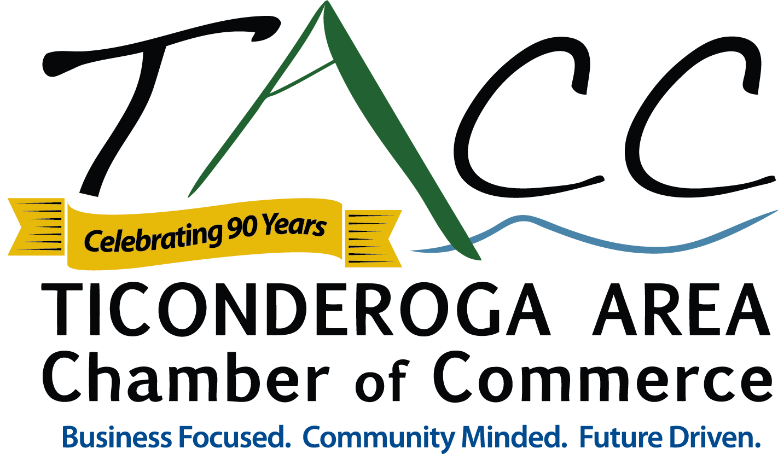

Press Release

FOR IMMEDIATE RELEASE:

CONTACT:

Matthew Courtright, Executive Director

Ticonderoga Area Chamber of Commerce

mcourtright@ticonderogany.com

518-585-6619

Fall 2015 Business Seminars

Ticonderoga, NY – August 14, 2015 - The Ticonderoga Area Chamber of Commerce (TACC) in coordination with the North Country Small Business Development Center are pleased to announce they will host two Small Business Seminars this fall.

Wednesday, September 23rd: 9:00 - 10:30 AM Demystifying Credit Card Processing
Is your business ready for the new Credit Card Terminal Requirements? If not, then this workshop is for you! Join us as Barbara Denis, senior account executive at TransFirst Merchant Services a partner of Glens Falls National Bank, explains the different fee structure on your business credit card processing statement as well as the new EMV (smart chip) technology requirements. Topics covered during the presentation will include: What is Chip Technology? How am I impacted by the liability shift? Am I required to support the new chip technology? Am I PCI compliant?

Presented by TransFirst Merchant Services in coordination with the NCSBDC.
Networking & sign in begins at 8:30 AM. The presentation will start promptly at 9:00 AM.
Refreshments Sponsored by: Glens Falls National Bank.

Wednesday, October 14th: 5:30 - 7:00 PM
10 Tips for Growing Your Small Business with Instagram
Instagram is one of the most popular social media networks on the web, with over 100 million users and growing! During this presentation, Amberly Rundell, Social Media Strategist at Mannix Marketing will teach you 10 creative ways to use Instagram to boost your online marketing presence for your small business. Additional topics include: The Basics: What is Instagram and why should you use it for your business, How to set up your account, Examples of engaging content, Hashtags, Videos, Contests, Successful Case Studies, Tips, Tricks, and more!

Presented by Mannix Marketing in coordination with the NCSBDC.
Networking & sign in begins at 5:00 PM. The presentation will start promptly at 5:30 PM.
Refreshments Sponsored by: Walmart of Ticonderoga.
MORE
Seminars/Workshops are free for TACC Members and $10.00 For Not-Yet Members.
Registration is required for both business seminars.

For more information or to register contact the Ticonderoga Area Chamber of Commerce at 518-585-6619, chamberinfo@ticonderogany.com or visit www.ticonderogany.com.

The Ticonderoga Area Chamber of Commerce – The Ticonderoga Area Chamber of Commerce (TACC) is a non-profit organization that serves, markets, and promotes the Ticonderoga area including, Ticonderoga, Crown Point, Hague, Moriah, and Putnam, NY. TACC’s vision is to be the leading advocate for business, serving as a driving force in the economic vitality of the greater Ticonderoga Area, uniting communities and maximizing resources. The mission of the TACC is to initiate and provide programs, services, and leadership which will enhance a cooperative business community and create a vibrant economy, making the Ticonderoga Area an exceptional place to live, work, and visit. The Ticonderoga Area in New York is located in the Adirondacks along Lake Champlain and Lake George. For more information on the Ticonderoga Area Chamber of Commerce or the Ticonderoga Area please visit www.ticonderogany.com, “like” the Chamber on facebook, “follow” TiconderogaADK on twitter, or TiconderogaNY on Instagram.

###

