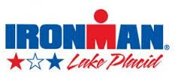
2015 Ironman Dine Around Form

Again this year, Ironman would like to offer each athlete a $25 gift certificate to use at participating area restaurants.

- The restaurant gift certificate is valid July 23-27, 2015.
- The balance over $25 is the responsibility of the costumer.
- The $25 gift certificate can be applied to tax.
- There is no balance or “cash back” on any purchase less than $25.
- All gift certificates will be submitted, by participating restaurants, to the ROOST office no later than July 31, 2015 for reimbursement.

Please reply if you would like to participate or if you will decline this opportunity.

Please fill out the information below and return no later than Monday, May 25, 2015 to bethany@roostadk.com

Participating__________

Not Participating_______

Name of Restaurant___________________________________________

Contact Name________________________________________________

Contact Email Address___________________________________________

Billing Address________________________________________________

